Changes / Improvement in the Application:

Info Article : (Same changes for blog post/article rewrite- info/money)
- Keyword checking exactly as it is in-
- H1
- H2
- Body description (2 to 3 times )
- Conclusion
- External Link to Govt, NGO or any Research Paper from Google scholar or other research sites
- Image Issue- Not generating article related image (new test check video )
- LSI keywords- used maximum 1 or 2 times either in description or H2 . Make sure main keyword use more than that other wise search engine will get confused about the topic. LSI 1 time will b okay.
- Make sure description of any bullet points or points not 1 liner. At least 3 sentences.
- Add Hero Image

Money Article (Same changes for Amazon round up/ single product review) :

- Keyword checking exactly as it is in-
- H1
- H2
- Body description (2 to 3 times )
- Conclusion
- After H1 no heading 2 direct intro
- Add product number
- External Link to Govt, NGO or any Research Paper from Google scholar or other research sites
- “Check Price On Amazon” hyper text should b button
- Length -3500 words length atleast
- Make sure description of any bullet points or points not 1 liner. At least 3 sentences.
- Add Hero Image
- LSI keywords- used maximum 1 or 2 times either in description or H2 . Make sure main keyword use more than that other wise search engine will get confused about the topic. LSI 1 time will b okay.

Cheetah link-
Add interlinking option to the sites along with interlinking suggestion

In overall apps add couple of features-

4-A) Cheetah writer-
- In Cheetah writer AI image and Youtube video option add just an image option no video only image option .Check the image below .
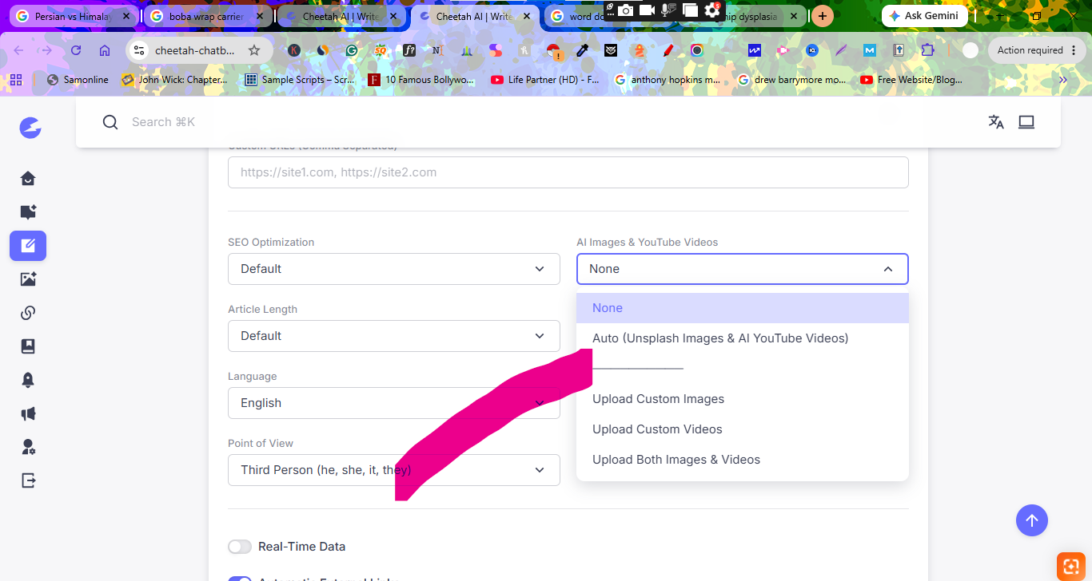
- Also not just only add unplash as free resources ,also add other free image sites like- https://pixabay.com/ & https://www.pexels.com/
- And change the name “Auto (unplash image & Ai Youtube videos) to Royalty free Images & youtube videos. And new option name – royalty free image

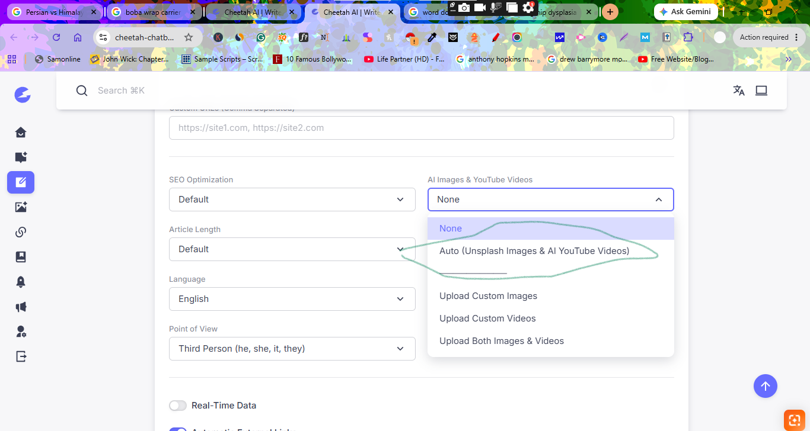

4-B) Other features to ADD-
- Wp published (Auto and draft)
- Meta title / description add
- Affiliate link to Amazon product round up and single product
- Change app name (will tell u later)

